2024

# October

October 1

Perform research on the algorithms on tank wheel movement, which included a formula for turning radius. This is turning radius for given left and right wheel speeds and distance betwee left and right wheel (b). We want to ensure whether it can proceed in an arc without hitting a tree 2 meters away if it is unable to turn in place. Still unsure whether it can turn while staying in place.

Installed Ubuntu Linux to use for coding.

October 7

Due to campus closure for Tuesday-Friday from hurricane Milton, I met in the lab on Monday with Andrea and Sebastian. I installed Arduino on my computer, and ran code given by Andrea to test the movement of the robot. Got all 4 wheels moving eventually but there are issues relating to the lack of power given to one of the motors and uneven speed of the wheels. Posted images with labels to Discord chat to provide some details on the rover shown below.

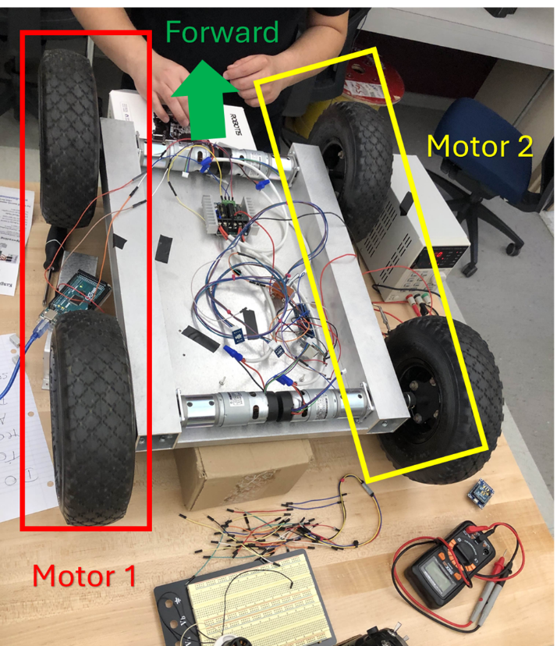

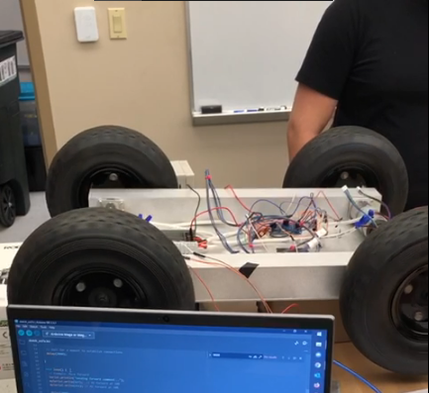

October 29

Added use case diagram to the SRS

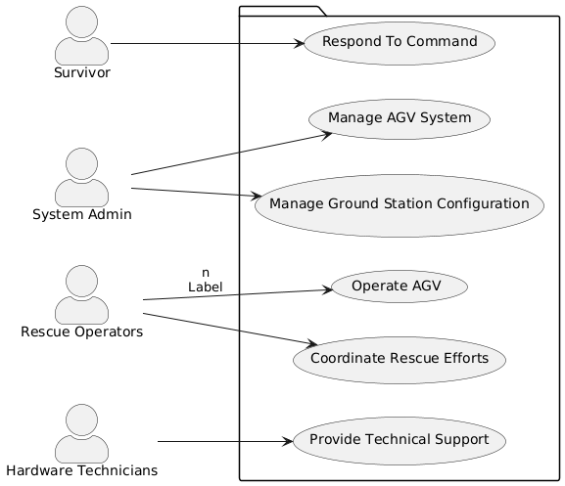

And database requirements regarding the user table, attributes username, hashed password, role and their respective permissions.

October 31

Reviewed requirements by others in the SRS.

# November

November 4

Created a context diagram for the SDD

November 6

The software subteam need to install Ubuntu OS onto the Rasberry Pi device. I’ve done some research into how that could happen. It could be done with a SD card or a USB flash drive but we chose the flash drive. Downloaded the Raspberry Pi Imager. Downloaded OS to San flash drive.

The goal is getting ths Rasbian OS on computer.

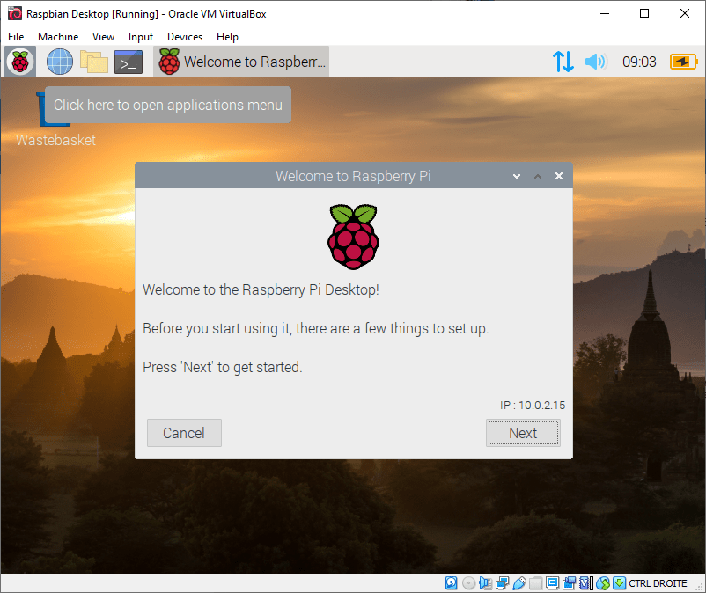

November 15

Connected the HDMI cable, power cord, USB cable, and the flash drive with connection to a desktop but nothing happened.

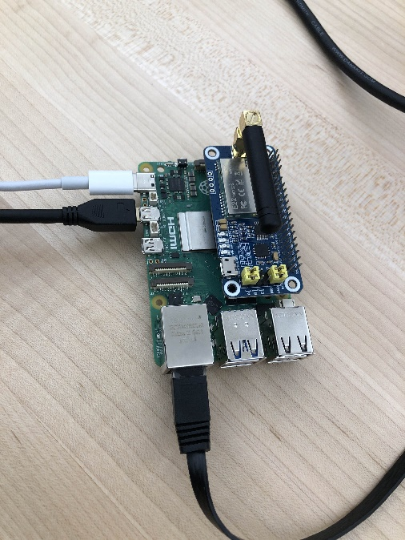

November 16

Tried booting my laptop using the flash drive with Raspberry PI OS but got this error.

November 18

Bought poster boards from Walmart to use for the poster display.

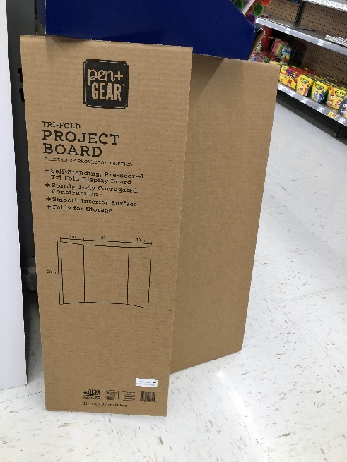

November 19

Matthew came today and got it working using the lab computers. However, we found out that an SD microchip is still needed. George ordered the parts and will arrive in the future.

November 25

Replaced technition user into robotics operator as a user in the use case diagram.

# December

December 1

In preparation for adding test cases, and the relevant tables for the testing plan, I’ve designed tables in google sheets, for easier viewing, organization, and management of the information. Imported requirements from the existing requirements. In google sheets, several things have been automated for efficiency, like enforcing consistency between requirements per test and tests per requirement. This tool got used by other members.

Some things members would want to know:

* requirements that need testing or don’t need testing
* requirements for each test case
* test cases for each requirement

December 3

Recorded video presentation with the other members of the software subteam. I talked about the slides for the class UML diagram.

December 5

Filled out the tracability matrix in the testing doc and optimized the google sheets tables for readability of the test cases.

